LuxSenz receiver hardware description

The LuxSenz receiver can be used to pick up LuxSenz signals and to decode those signals using the STM32 microcontroller.

# System overview

The hardware of the receiver converts the light-encoded signal in an electronic digital signal and decodes received messages. The signal is captured with a light-sensitive phototransistor, filtered, amplified and sampled into a digital signal with an ADC. The digital signal is further processed (digital filters and decoding) on a STM32 microcontroller, that gives output on a connected e-Paper display. Details about the processing by the microcontroller can be found in the document “LuxSenz receiver software”.

The PCB dimensions are 20.8mm x 50.1 mm. The analogue and digital components are spatially divided between two surface parts of the board. The images below show the design of the PCB, of which the left image shows all PCB layers and the cut between the digital and analogue power planes.

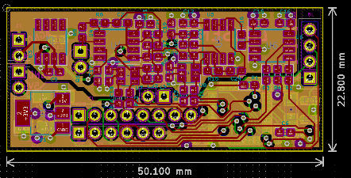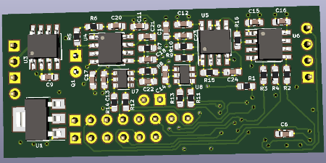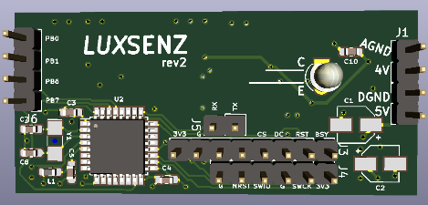

# Power inputs and voltage regulators

The analogue and digital parts of the board are powered separately, by separate lithium batteries. The ground inputs of the boards must be connected externally. Resistors R2, R3, R4, R11, R12, R13, R14 are placed on the traces between the analogue and the digital parts and should have a value of approximately 1k5 to prevent leakage currents and noise coupling.

The analogue voltage input (between 3.3V and 5.5V) is used directly as power source for the operational amplifiers (op-amps) and ADC. A TLE2425xD from Texas Instruments is used to generate a 2.5V reference voltage that is used in the amplification circuits.

The digital voltage input is converted to 3.3V to be used as power source of the microcontroller and a connected e-Paper display.

## Charging the batteries

Two TP4056 modules are used to recharge batteries. A solar panel is connected as a sustainable power source, to enable 24/24h operation outdoors. Additionally, by using one (not both, the inputs are connected in parallel!) micro USB inputs on these boards the batteries can be recharged.

# Shielding

Shielding is added by copper tape around the insulating PCB box. The shield is connected to the analogue ground input. The shielding reduces noise on the amplification circuit induces by radio waves.

# Sensor: phototransistor

The used sensor is a TEPT4400 phototransistor produced by Vishay semiconductors. It has a higher photosensitivity compared to most other phototransistors and photodiodes and a relatively small sensitivity angle (30°). A lens is placed in front of the sensor, to increase the sensitivity of the receiver. The size of the gap is optimized for indoor usage, one might want to cover it partially when installing the setup outdoors.

# Transimpedance amplifier

A phototransistor induces a current based on the power of the incident light. This transimpedance amplifier has an 68kOhm resistor to convert the generated current to a voltage for further filtering. The resistor value (R5 = 68k) is at least suitable for indoor usage. One might want to decrease the value when installing the setup outdoors, or increase it when the size of the gap is decreased.

# Band-pass filter

An active band-pass filter is used to isolate the FSK signal from waves at other frequencies. The filter must be tuned to amplify the frequencies of the FSK signal from the transmitter. Potentiometer U7 was meant to make a frequency tuneable filter, but it resulted in an unwanted effect of having a slowly integrating output signal. U7 and C22 are often not placed on the PCB.

The following configurations were tested:

* Centre frequency 588 Hz: R6 = 300, R7 = 47, R8 = 1k8, C20 = C21 = 1uF, C22 and U7 left open
* Centre frequency 391 Hz: R6 = 300, R7 = 68, R8 = 3k, C20 = C21 = 1uF, C22 and U7 left open
* Centre frequency 810 Hz: R6 = 300, R7 = 68, R8 = 3k, C20 = C21 = 570nF, C22 and U7 open

# Signal amplifier

The third amplifier stage is a simple inverting amplifier, increasing the amplitude of the signal. The PCB allows to add a different filter topology, but until now it hasn’t been used. R10 is a 0 Ohm resistor, C23 and C24 are left open circuit. U8 could be used to make the amplification factor dynamically, but is usually left open also. Exemplary values are R9 = 560, R15 = 110k (high amplification factor) or R9 = 1.3k, R15 = 1k8 (very low amplification factor). The amplification factor of this inverting circuit should always be larger than 1.

# Signal buffer

A unit-gain amplifier is used to buffer the output voltage of the amplification circuit and the input voltage of the ADC. The ADC is connected with a 2.2kOhm resistor (R16) for input stability of the ADC.

# Analog-to-digital converter

A 12-bit MCP3201 ADC from Microchip is used to sample the amplifier output signal. The wires connecting the ADC to the microcontroller on the digital part of the PCB have 1.5kOhm resistors to reduce leaking currents and noise between the digital part and analogue part of the board.

# Microcontroller

An STM32L031K6T6 microcontroller from ST Microelectronics is used to process the digital signal and control the e-Paper display.

# Connectors

The following connectors are present on the PCB:

* J1 - Analogue power input: Ground and 4V (may range between 3.3V and 5.5V).
* J2 - Digital power input: Ground and 5V (may range between 3.3V and 7V). Should be disconnected when the microcontroller is connected to a programmer.
* J3 - E-paper connector: 8-pins on which the e-Paper display can be connected
* J4 - ST-Link connector: 3.3V, SWCLK, Ground, SWIO, NRST, Ground. First 4 pins must be connected to an ST-Link programmer to upload software to the microcontroller. Digital power input should be disconnected when 3.3V on J4 is connected to a programmer.
* J5 - UART connector: RX, TX. Can be used when UART communication is enabled in the receiver software.
* J6 - GPIO connector: PB0, PB1, PB6, PB7. Four general purpose input/output pins of the microcontroller that are available.

Analogue and digital ground input pins of J1 and J2 should be connected externally to keep ground voltage levels equal with maximum noise decoupling. Usually these pins are connected by connecting the ground input pins (IN–) of the battery charger modules.

# PCB Changelog

## Version 1: Receiver (project pcb2)

Initial version. Multiple boards are available at TU Delft, Embedded Software group.

A few notes:

* U1 must not be soldered centred on its connection pads. It should be moved a bit away from the edges of the PCB, such that the PCB will fit into the casing.

## Rev2: Transceiver (pcb4)

* Connectors J1 and J2 placed adjacent, such that a 4-pin connector can be used to connect both the digital and analogue power inputs.
* Capacitor C10 moved to the other side of the PCB
* Explicitly indicate the collector and emitter pads of the phototransistor (Q1)
* Moved voltage regulator U1 a few mm, such that it can be soldered normally on its pads.
* Removed variable resistors
* Added U9 (op-amp) to drive shutters and enable transmission